

**ACLC Lead Facilitator Report – David Hoopes**

**Board of Directors Report**

**October 18th and 20th, 2016**

ACLC Self Study Complete and submitted to the Western Association of Schools and Colleges on October 13th. The WASC visit will be 11/14/2016 through 11/16/2016. Copies of the document were printed and mailed to the four members of our visiting committee.

* Chair: Mr. Rafael Aguilar -Principal
* Member: Ms. Jamie Cutter -Teacher, Advisor
* Member: Ms. Desire Deane Hanson -Teacher
* Member: Mrs. Julia Keller -Education Liason and Specialist

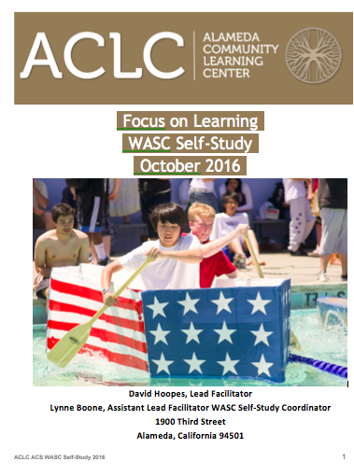

The Self-Study Full Visit has five objectives. Raphael and his team will seek to accomplish the following:

1. Involvement of all stakeholders in the self-study process.
2. Clarification of the school’s purpose and the schoolwide learner outcomes.
3. Assessment of the student program and its impact on student learning with respect to the ACS WASC criteria.
4. Development of a schoolwide action plan that addresses identified areas for improvement.
5. Visiting committee validation and enhancement based on accreditation criteria and standards, self-study, and findings from the visit.

**Priority application period for 2017-2018 is open**

Though the school year has already started, we are still accepting applications for the 2016-17 school year. While some grades are fully enrolled, there remain a few open spots in certain grades.

The ACLC lottery will be held on February 1, 2017, for applications received between October 15, 2016 and January 31, 2017. Offers of admission based on the lottery outcome will be sent by email and/or text message beginning February 8. Admission offers are based on lottery outcomes and will continue until all grades are filled. To check learner’s status, families can [log-in to SchoolMint](https://clcschools.schoolmint.net/signin).

If a child is not offered a spot, their name will be placed on a grade-level waitlist, according to lottery placement. As the offer process continues, we will proceed down the waitlists, as spaces are available. Families can check their child's lottery/waitlist position by [logging-in to SchoolMint](https://clcschools.schoolmint.net/signin) after February 2, 2017.

The ACLC charter provides that Alameda residents, children of staff and board members and siblings of current attendees of ACLC are granted priority admission status. All siblings MUST clearly identify on their application that they are siblings in order to receive priority in the lottery.

**FAMILY INFORMATION SESSIONS &  SCHOOL SITE TOURS**

Flyer ACLC 9_29_16-3

**Current Enrollment**

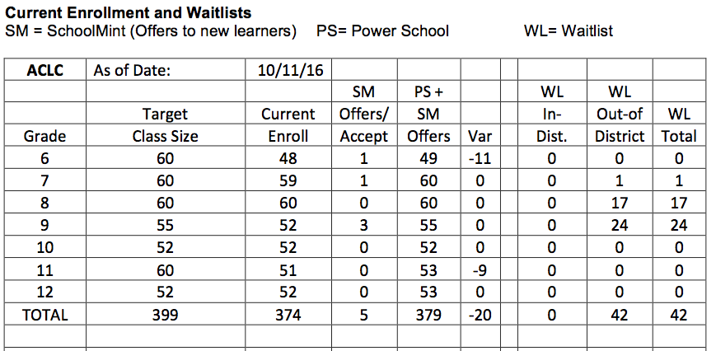

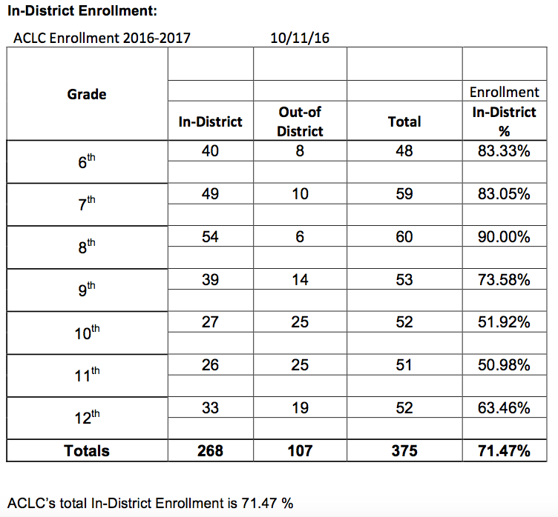

**Staffing update:**

The decision was made to not hire a campus supervisor until enrollment increases to 385.

**Spirit Gear:**

We’re happy to introduce you to ACLC’s all new gear! We're now using AGL School Spirit, a small business located right here in Alameda. To check out ACLC's new t-shirts, sweatshirts, tote bag, hat, and car magnet, visit [http://aglschoolspirit. com/ aclc#](http://aglschoolspirit.com/aclc)

1. Ordering will be **online only** at [http://aglschoolspirit.com/ aclc#](http://aglschoolspirit.com/aclc).
2. Payment is made online at the time you order.
3. Please place your order online by **November 7**. Everything ordered by November 7 will be delivered to ACLC in early December.
4. A parent volunteer will be on campus in early December to hand out the gear you've ordered.
5. A portion of all proceeds goes to CCEF.

Questions? Contact ACLC parent Amy Garcia at [amyj33@yahoo.com](mailto:amyj33@yahoo.com).



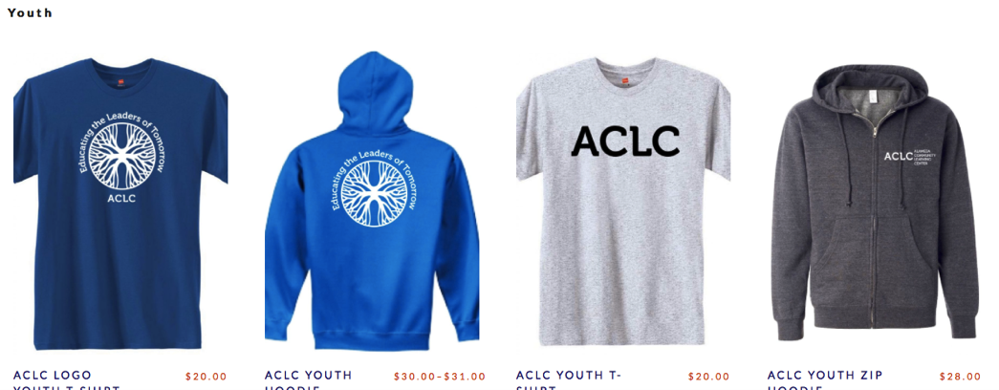



**BIIG Internet Connection switch:**

Our BIIG Grant to have faster internet connection and more bandwidth is finally in place and running! Some of you may remember that Calvin applied for the BIIG Grant about 2 years ago. We now have a new working circuit.

What does this mean? Before ACLC use to be limited to Bandwidth with heavy usage. This problem will cease to exist in the future as our direct connection is now on average 118-200mbps in each room versus sharing 100mbps as a whole site. The connection also stays solid and does not drop due to the fiber optic cabling we now have.

**PAC Update**

The 1st of the Parent Couch Nights is coming up on Wed. Oct. 19th 7-9pm in the Center.

PAC-sponsored Couch Nights are a chance for parents at ACLC to come together to give and get support on a variety of topics.  Sometimes the gatherings are unstructured with topics chosen by those who show up each particular night. The conversations have been everything from what makes ACLC special for our learners to issues around parenting teens to hopes and wishes for the school community, and more.  Other times, the Couch Nights have had guest speakers.  Our first Couch Night this year will be an open conversation with the suggested topic to kick us off: how to teach/foster "life skills" with our teens and tweens.

In January,  Couch Night will feature guest speaker Elizabeth Dandenell, MFT on the topic of supporting teens and tweens with anxiety/stress

On March 8th, Couch Night will feature guest speaker psychologist Michael Torres, P.hD. on the topic of supporting our teens and tween in the minefield of high risk behaviors, with an emphasis on concerns re: over-use of technology

PAC Meeting Schedule 2016-2017

Tues. Sept. 6,  8:30-10:30am

Tues. Oct. 11   8:30-10:30am

Wed. Nov. 30 Joint PAC/CCEF meeting (time to be confirmed, likely at 6:45pm)

Tues. Dec. 13,  8:30-10:30am

Wed. Jan. 11,  6:45-8:45pm

Wed. Feb. 22  Joint PAC/CCEF meeting (time to be confirmed, likely at 6:45pm)

Tues. March 14,  8:30-10:30am

Wed. April 12,  6:45-8:45pm

Tues. May 9,  8:30-10:30am

**CCEF Update**

The first CCEF meeting was a big success. CCEF has a full board and once again is off to a strong start in fundraising for our learners. If you would like to submit a request for funding, please do so.

* Complete the CCEF Funding Request form, be as detailed as possible, include budget, cost of materials or specific items, and the number of volunteers needed.  It is helpful to know the number of learners that will benefit from the project or funded item.
* Please feel free to contact the CCEF Board President or the CCEF Treasurer, Kris Thornton ([hazeltonklt@gmail.com](mailto:hazeltonklt@gmail.com)) with any questions, for advice or any problems with the funding request form.
* Send the completed CCEF Funding Request Form to the CCEF President as soon as possible before the meeting you’ll be attending. You can email or drop off the form in an envelope addressed to CCEF President in the ACLC office. Please email or call the CCEF President to inform that you have left the funding request in the ACLC office.
* The CCEF President will let you know the date of the meeting when the funding request will be on the agenda. When there is a time constraint on a funding request, the CCEF Board tries to be responsive, sometimes the funding request can be placed on an agenda at the last moment. You may simply show up at a CCEF meeting and hope there is room on the agenda, although your request may be tabled for a future meeting.
* If the request requires Leadership approval, please obtain Leadership support or approval before the CCEF Board addresses the funding request.
* You will have less than 5 minutes to present your request and answer questions.
* The CCEF Board requests that you or one of the requestors be present to answer the Board’s questions. The funding request may be tabled for a future meeting if the requestor or one of the requestors is not present to answer the Board’s questions.
* The CCEF Board has the option of giving a decision on the request at a later date.
* CCEF would like to make matching grants in the case of sports funding requests and would like a detailed budget submitted on or with the request form.

2016/2017 CCEF Meetings

(CCEF generally meets the last Wednesday of each month)

September 28th, 2016  6:45p.m.                              February 22th, 2016   Joint PAC/CCEF

October 26th, 2016       6:45p.m.                              March 29th, 2016    6:45p.m.

November 30th, 2015   Joint PAC/CCEF                  April 26th, 2016      6:45p.m.

December 14th, 2015    6:45p.m.                           May 31st, 2015  CCEF Annual Meeting

January 25th, 2016        6:45p.m.

**ACLC Mock Election**

ACLC held a school wide mock election that included cross-curricular and cross grade level presentations. It was a huge success. Ive added results below for you to see. Also, here is a link to the State of California Mock Election Results (very similar to ours it seems):

[studentmockelectionresults.sos.ca.gov/](http://studentmockelectionresults.sos.ca.gov/)

Big thanks go to: high school learners for a great job facilitating; middle school learners for being such a great audience; Humanities facilitators for giving up class time and making this project happen; all other facilitators for letting learners out of class at inconvenient times; and BIG THANKS TO THE WHOLE SCHOOL FOR VOTING!

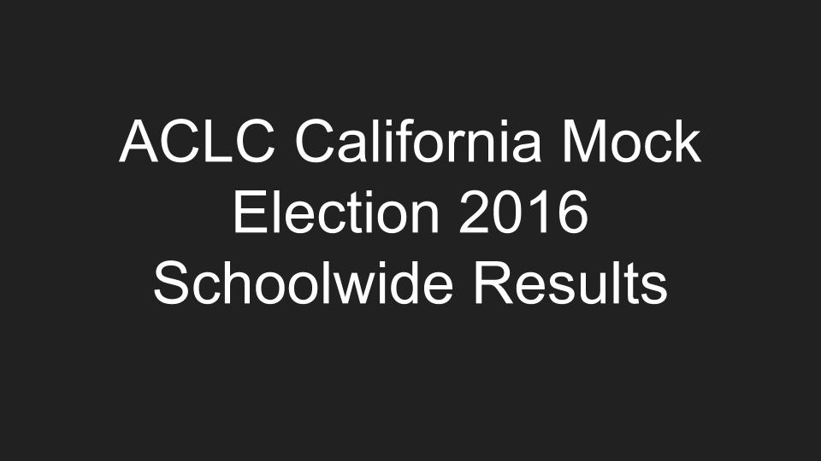

**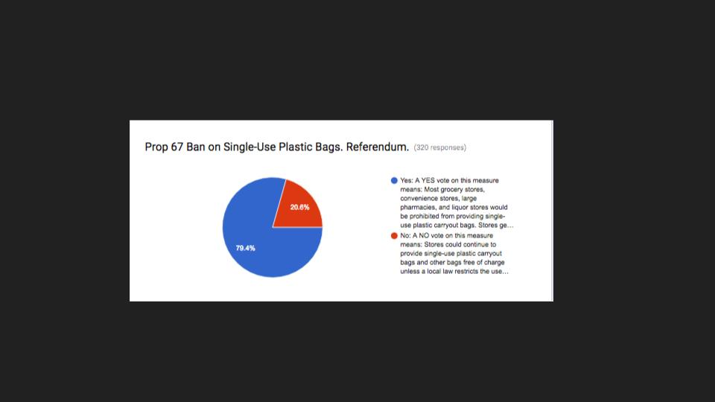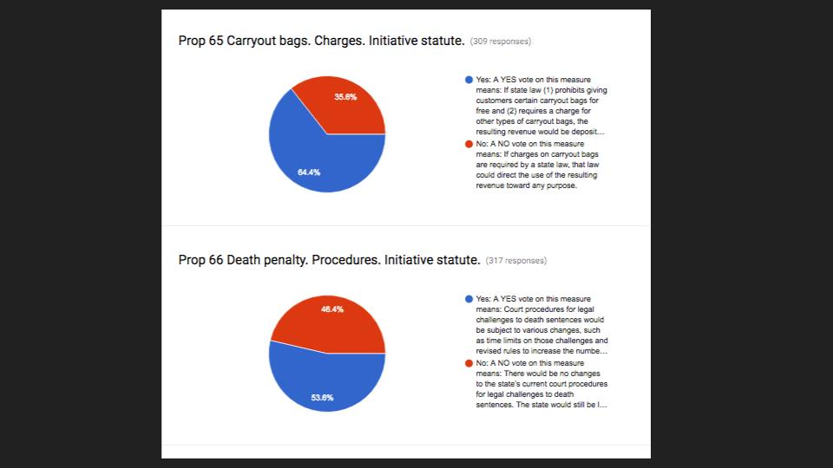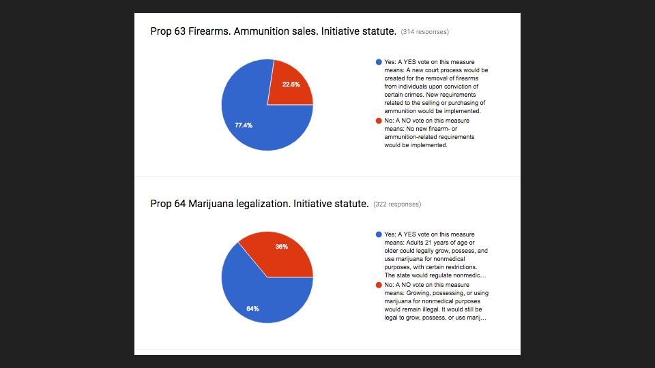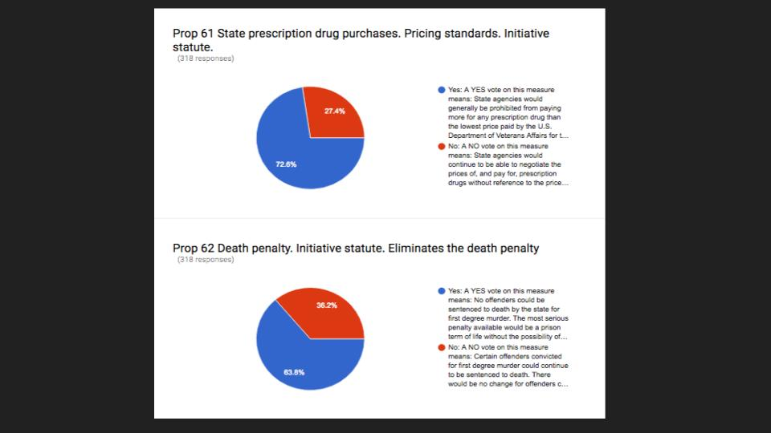**

**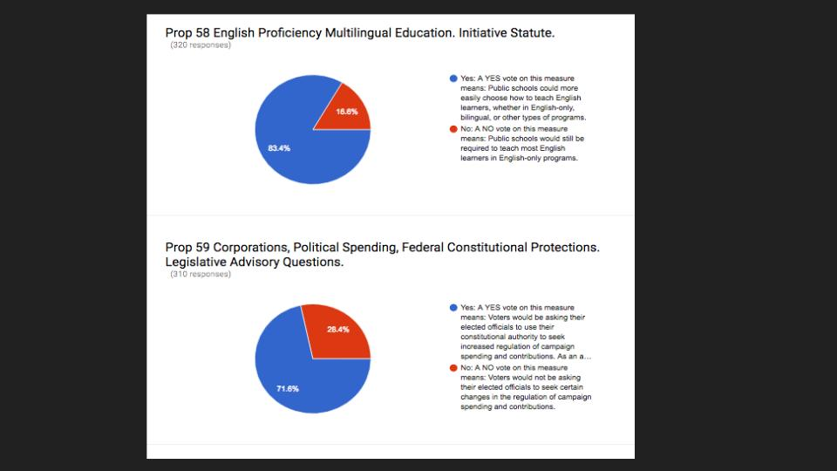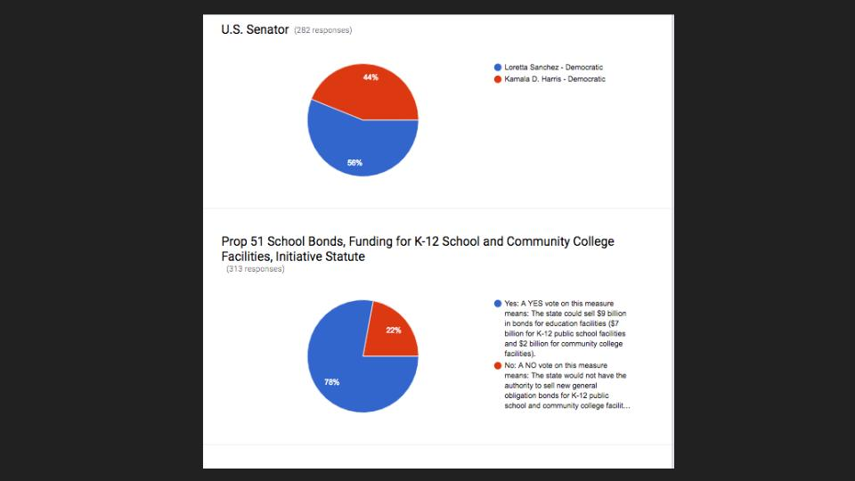**

**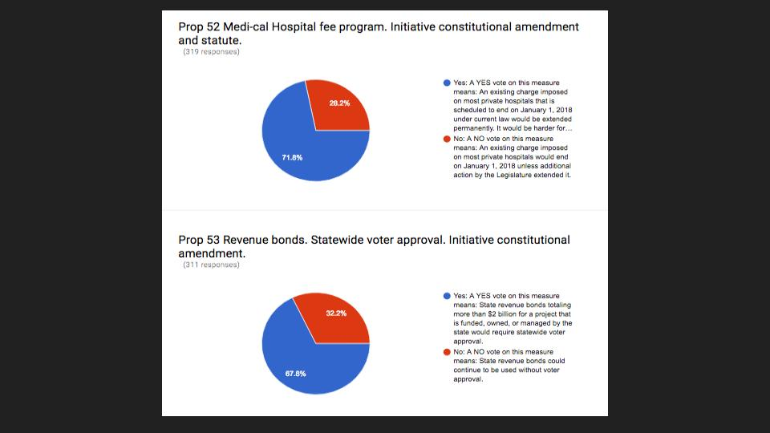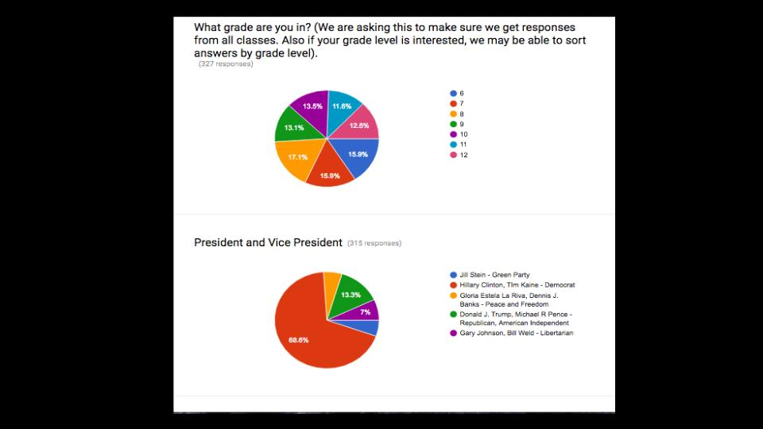**

**Hannah Camp**

Hannah camp here and we are very excited for the fun bonding that will be happening next week. We will be departing after school on Wednesday and returning on Friday. **On Thursday night, learners, parents and facilitators are all invited to dine under the stars at our community potluck!** Learners will be performing skits based on our space theme. They are always quite entertaining.

We would love to have all of you join us in celebrating this invaluable tradition at ACLC. Feel free to bring a main/side dish, drinks or deserts and come with family. ACLC will be at the Hawk Ridge campsite in Anthony Chabot Regional Park starting at 5:30. We recommend carpooling since the parking lot is pretty small.

**ACLC Committee Schedule Draft:**

The entire community is invited to attend committee meetings held monthly. Please know that these are open meetings for the entire community to attend.

|  |  |  |  |
| --- | --- | --- | --- |
| **2016-17 ACLC Committee Schedule** | | | |
| **Committee** | **Chair** | **Location** | **Time** |
| Program Evaluation | Madeline Palmer | Room Quiet Area/ Room 10 | @3:30 |
| Curriculum | Adri Lombard | Room 21 @3:30 | @3:30 |
| Finance | Patti Wilzeck | Room 14 @3:30 | @3:30 |
| Personnel | David Hoopes | Room 23A @3:30 | @3:30 |
|  |  |  |  |
| **October** | Committee | Date |  |
|  | Program Evaluation | no meeting |  |
| Curriculum | Mon, Oct 17th |  |
| Finance | Tues, Oct. 18th |  |
| Personnel | Monday, Oct 24th |  |
| ACLC Board meeting | Tues, Oct 18th | All Committee Chairs attend |
| **November** |  |  |  |
|  | Program Evaluation | Mon, Nov 1st |  |
| Curriculum | Mon, Nov 14th |  |
| Finance | Tues, Nov 15th |  |
| Personnel | Monday, Nov 29th |  |
| ACLC Board meeting | Tues, Nov 15th | All Committee Chairs attend or report in writing |
| **December** |  |  |  |
|  | Program Evaluation | Mon, Dec 6th |  |
| Curriculum | Mon, Dec 12th |  |
| Finance | Tues, Dec 13th |  |
| Personnel | Monday, Dec 20th |  |
| ACLC Board meeting | Tues, Dec 13th | All Committee Chairs attend |
| **January** |  |  |  |
|  | Program Evaluation | Mon, Jan 9th |  |
| Curriculum | Mon, Jan 23rd |  |
| Finance | Tues, Jan 17th |  |
| Personnel | Monday, Jan 31st |  |
| ACLC Board meeting | Tues, Jan 17th | All Committee Chairs attend or report in writing |
| **February** |  |  |  |
|  | Program Evaluation | Mon, Feb 6th |  |
| Curriculum | Mon, Feb 13th |  |
| Finance | Tues, Feb 21st |  |
| Personnel | Monday, Feb 27th |  |
| ACLC Board meeting | Tues, Feb 21st | All Committee Chairs attend |
| **March** |  |  |  |
|  | Program Evaluation | Mon, March 6th |  |
| Curriculum | Mon, March 13th |  |
| Finance | Tues, March 14th |  |
| Personnel | Monday, March 20th |  |
| ACLC Board meeting | Tues, March 14th | All Committee Chairs attend or report in writting |
| **April** |  |  |  |
|  | Program Evaluation | Mon, April 10th |  |
| Curriculum | Mon, April 17th |  |
| Finance | Tues, April 18th |  |
| Personnel | Monday, April 24th |  |
| ACLC Board meeting | Tues, April 18th | All Committee Chairs attend |
| **May** |  |  |  |
|  | Program Evaluation | Mon, May 1st |  |
| Curriculum | Mon, May 15th |  |
| Finance | Tues, May 16th |  |
| Personnel | Monday, May 22nd |  |
| ACLC Board meeting | Tues, May 16th | All Committee Chairs attend or report in writting |
| **June** |  |  |  |
|  | Program Evaluation | Mon, June 5th |  |
| Curriculum | Mon, June 12th |  |
| Finance | Tues, June 13th |  |
| Personnel | Monday, June 12th |  |
| ACLC Board meeting | Tues, June 13th | All Committee Chairs attend |

**Learner’s in the News:**

ACLC's own Jordan Yu was mentioned in the Alameda Sun yesterday as the youth recipient of the annual Alameda Women Artists award.  The article mentions that the 23rd Annual Alameda Women Artists exhibit will be held at the Alameda Museum (2324 Alameda Ave.) from Oct. 7th to the 29th.  Congratulations Jordan!  Your community celebrates you!

**Suspension and Expulsion update:**

|  |  |
| --- | --- |
|  | **September and October 2016** |
| Expulsions | Zero |
| Suspensions | one |

Year Total Suspensions: 1 Year Total Expulsions: 0

**504 update**

|  |  |  |
| --- | --- | --- |
|  | **October 2016** | **Pending** |
| 504’s | 32 | 2 |
| IEP’s | 40 | 4 |