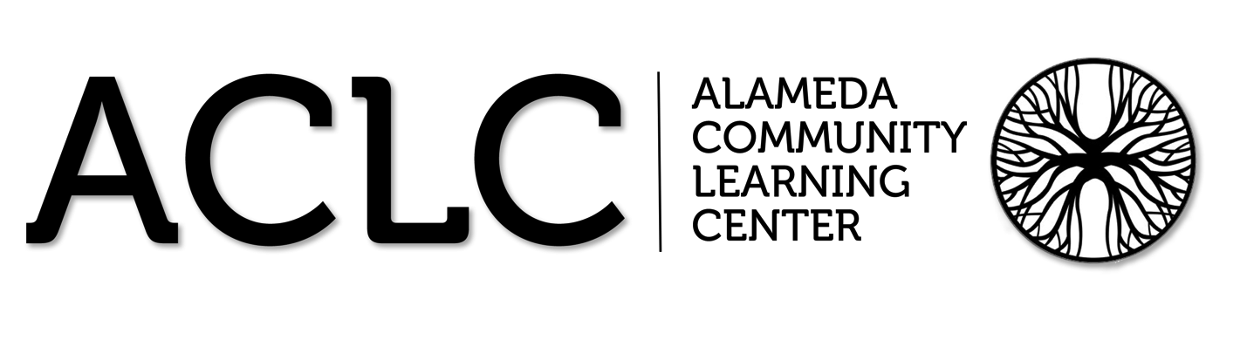

ACLC Lead Facilitator Report – David Hoopes
CLCS Board of Directors
December 17th, 2015

Summary of report
- ACLC Constitutional Convention
- An Hour of Code
- ACLC Board Update
- Staffing update
- 8th Grade Forum Update
- Lock Down Reflection
- Professional Development
- Job description review for LF and ALF
- ACLC Facebook
- WASC School Action Plan update
- Leadership Conference – Feb 11th
- Winter Warming Hut
- Enrollment Plans for ACLC
- Suspensions and Expulsions
- IEP and 504 update

ACLC Constitutional Convention
On November 16th we had our annual Constitutional Convention. It was phenomenal this year. Thank you to all of our learners who organized the convention and facilitated rich and energetic conversations. This year over 30 proposals came out of these discussions. Constitutional Convention is a yearly event where an entire school day is dedicated to hearing input from the student body on topics about ACLC.
Topics included:
Inside relations (inside ACLC relations like facilitator/learner relations) outside relation (relations to the outside world like Nea),
Environment (how we impact the environment),
JC (judicial committee, usually goes over rules),
Space (our new campus),
Leadership (the leadership class),
School spirit (ACLC spirit),
Academics (our academic structure),
Democracy (our democratic structure)
An Hour of Code
This year ACLC participated in an hour of code. The Hour of Code is a one-hour introduction to computer science, designed to demystify code and show that anybody can learn the basics. Every student should have the opportunity to learn computer science. It helps nurture problem-solving skills, logic and creativity. By starting early, students will have a foundation for success in any 21st-century career path. Almost all of ACLC learners participated.
Winter Warming Hut
On the last day of school before Winter Break (Fri. Dec. 18th) at lunchtime (12:25 to 1:05), ACLC and NEA's Upper Village will share some good cheer as we celebrate everyone's hard work in this first part of the year. We'll be out there rain or shine on the shared blacktop of the two schools (or under awnings if needed). Caterer, Pacific Fine Food is once again generously donating hot cocoa and cider.

As in past years, we need baked goodies (lots of them) from our fabulous families to make this party a success. We are looking for 800 servings in all to treat learners and staff of both schools. This event is free to all youth and staff.

Chilly Cook Off
This proposal is for all elements related to the planning and execution of the CCEF Chili Cook-off. This will be a family-friendly community- building fundraiser for CCEF. CCEF’s fundraising strategy for 2015- 2016 includes the concept of multiple smaller-scale inclusive events. This is the second for the school year. This event is for all ages and includes a chili competition with approx. 15 entries from families and learner teams. Everyone will have the chance to have a small taste of all the entries and then cast a vote. We’ll have prizes for the top 3 winners (and may have a professional chef-judged category as well). After the competition, diners go back with a bowl for a meal of chili, cornbread, salad and dessert. We’ll have a raffle as well. We’ll use wristbands to indicate “Over 21” to create safety with the alcohol.
Leadership Conference
We are excited to announce the ACLC second Leadership Conference! ACLC's model is to "Educate the Leaders of Tomorrow", and on February 11th, the entire school will learn to lead together. The Leadership conference was born from the idea many learners may have felt discouraged that they don't have any leadership skills and/or do not have a strong voice in the community because they are not in Leadership class.

This year, the theme of the conference is "See the Need, Take the Lead". Each session will include the following:

- Introduction of who they are, their background, and what they do.
- Inspirations and support of how they became a leader in the community.
- A connection to the theme of the conference of how to take lead.
- Advice for learners to become effective and successful leaders now and in the future.
- Any questions the learners may have.

If you or someone you know of would like to participate as a guest speaker volunteer for this conference, please email me.

ACLC Facebook
Bara Waters has created the ACLC Facebook Page. Please go check it out and "like" it at: www.facebook.com/AlamedaCommunityLearningCenter

We will use this page for updates about school events, announcements or news on relevant topics, information about the school and as a general community resource.

If you have an announcement, information and/or a photo you would like posted to the page, please email Bara at: bara.waters@clcschools.org

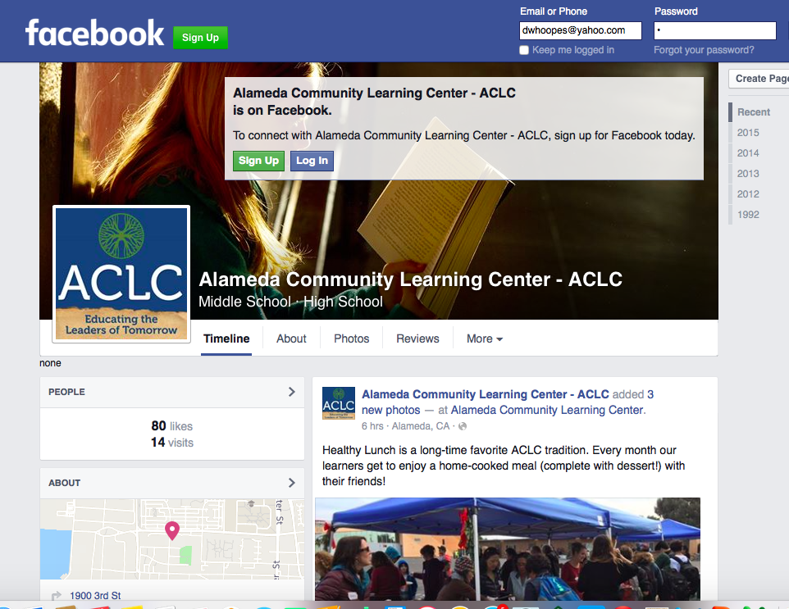

ACLC Board Update
At our December meeting the ACLC Board held discussion on the following agenda items.
  - Introduction of any parent board candidates from our community
  - Committee chairs bring their goals and expectations
    - The Board will provide feedback on goals
    - Provide clarity about what’s expected of committees
  - Staffing updates
    - 8th grade science and 8th grade math
    - Reflect on key points from community meeting held Nov 30th
  - Courtyard improvement updates
  - Independent Study agreement review of changes
  - Sending out a poll to learners with upcoming items & what’s important to them
  - Discussion of ACLC Board goals or projects this year
  - Harassment, Intimidation, Discrimination & Bullying Policy
  - Sexual harassment policy
  - Upcoming events – review school and leadership calendars
g. Future items for discussion or action

The ACLC Board has created goals for the 2015-16 school year. The Board members listed below the goal are working in a sub committee fashion to bring back recommendations to the ACLC Board or follow through on direction provided. The CLCS Board would probably appreciate knowing our ACLC Board goals and ACLC Committee goals. They are provided below:
ACLC Board Goals
- Do something about the Center. Learners have created a committee and are working through a process. Proposal likely coming to board next month for discussion. It is part of a learner’s senior project. Create a vision to make the center more vibrant should be a goal (e.g., couch from freecycle, with plans about how to keep it clean).
Lynn, Rebekah and David

- Recording and improving on the organization and board (e.g., committee goals and tracking progress toward these each year; organize a system to acclimate new board members; cycle of when things come up for the board outlined in a document; board members making a commitment to be connected with the school itself such as visiting/touring school & classes, attending a CLCS board meeting and/or an enrollment night, especially parents and community members on the board).
Jim, John and Patricia

- Leadership bringing proposals to the board sooner as a means of drawing more learners to meetings for greater engagement.
Adam and Sophia

- Policy/Document review and revision based upon what’s up on the websites
Patti and David

- Staff Retention: Learning about and improving staff retention
Sophia, Adam and David

ACLC Committee has all created goals for their work in the 2015-16 school year. This month most committee’s shared goals for the Boards review.
Curriculum & Standards Committee 2015-2016 Goals
1. Independent PE guidelines
2. Alameda Family Services health education presentations in all grade levels that don't already have it
3. Do appropriate WASC work for Curriculum chapters
4. Address issues presented to committee by community members with appropriate person or group

Program Evaluation Committee 2015-2016 Goals
1. PEC will revise and implement the 2015-16 mid and end year surveys.
a. Jupiter Grades from Illuminate?
b. How often do facilitators update?
c. Is the tool being used effectively?
d. Project Based Learning-
▪ How often do interdisciplinary projects occur?
▪ How do learners view their project-based learning?
e. Substitutes
f. Staffing
g. long-term substitutes
h. Are parents and learners satisfied with how the school has been handling the challenges of 15-16
2. PEC will accomplish all WASC accreditation year work
a. We will include all questions that the WASC leadership would find valuable
b. We will include collecting data for the school’s self-reflection and contribute to writing the WASC reflection
3. The committee will work to develop the Annual Report that reflects recommendations based on the annual survey.

Personnel Committee 2015-2016 Goals
1. The Personnel Committee will fill all long-term positions offered as soon as possible.
2. The Personnel Committee will work with CLCS to expand the Substitute pool for ACLC facilitators. This pool is so thin that facilitators are reluctant to take days off.
3. The Personnel Committee will celebrate facilitator birthdays and organize holiday celebration.
4. The Personnel Committee will ensure that Facilitator updates and posting on the web site and both media are updated and accurate.
5. The Personnel Committee will solicit new facilitator feedback and strive to support them both before and after they come to our school.
6. The Personnel Committee will convene to facilitate the firing process when full time facilitators are hired.

Finance Committee 2015-2016 Goals
To be completed and reviewed
Staffing update
Marc Leone was hired to be our CC3 and Geometry facilitator. He interviewed last week and taught a demonstration lesson. He was introduced to classes and will be starting Tuesday. Marc taught at Fame Charter School in San Leandro last year. He was here Friday and Monday doing the following preparation:
· Live scan and other human resources paperwork
· Lesson planning and unit planning
· Observing Daniel, Aaron and Patricia
· Working with Patricia to learn about CPM facilitator tools
· Become aquatinted with our ACLC model and ACLC mission
· Training on Jupiter Grades
· Training with Power School
· Updates on learners with 504 and IEP needs
· Purchasing and other logistical tasks
· Moving in and meeting the ACLC team

The hand off from Henry Maisler to Marc began last week. Marc began facilitating full time starting Tuesday December 15th in Core Connections 3 and Geometry classes.

8th Grade Forum Update
The eighth grade parent and learner community was invited to a discussion in the center. The discussion Agenda included a complete review of how we came to such an unsettled place in the eighth grade. In an effort to answer questions as well as bring to bear potential resources to assist in this situation, I scheduled a meeting of 8th-grade parents on November 30th. The meeting includes a variety of topics including
- An overview of our core challenge, which is finding highly effective facilitators to fill positions vacated by medical leave or resignation.
- Updates on the CC3 Hiring process
- Updates on supports being provided to our new Science Facilitator to improve classroom culture and management
- Opportunities for learners to assess into Algebra immediately
- Grading concerns as a result of grade fraud committed last month
ACLC is committed to providing additional supports to learners that move to Algebra and those that remain in CC3. CC3 classes are now much smaller as a result of this change.

Lock Down Reflection
- ACLC had a lockdown procedure that went very well. In a few minutes, the entire campus was locked down. The Share 911 tool was a little glitch but all in all the lock down and share 911 made folks feel safer and clear about what to do.

Professional Development
Discussions with ACLC Faculty took place over the last two weeks during professional development. Dr. Franklin led groups of facilitators and staff through a reflective dialogue on the staff culture. Dr. Franklin will provide the staff with a report that will inform our future professional development.
ACLC hosted Navdeep Purewel from the Alameda County Office of Education for a Digital Library and Interim Assessment Clinic: The session provided information and guidance on both the Digital Library and Interim Assessments. The clinic addressed topics such as using formative assessment practices to support teaching and learning in the classroom, promoting use of the Digital Library in LEAs, and considerations in administering interim assessments and interpreting results. Facilitators practiced accessing the digital library of items.

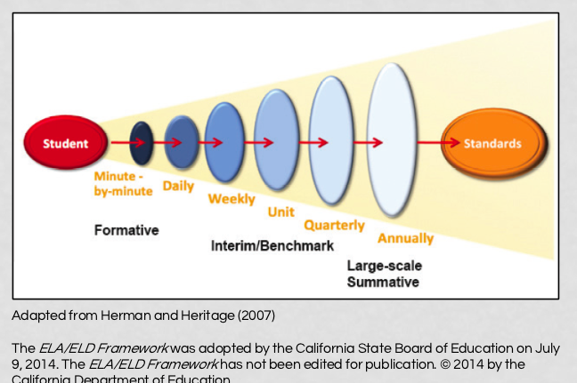

Job description review for LF and ALF
Patti, Lynne and I conducted a complete review of our job descriptions. We identified areas where we are overlapping and areas that needed clarification. The revisions were not significant but it provided us all with clarification of the LF and ALF circles of responsibility. It may be helpful for the Board to review these changes.

WASC School Action Plan update
WASC – WESTERN ASSOCIATION OF SCHOOLS and COLLEGES
WASC work is continuing with staff. Lynne Boone is leading this work along with the WASC Leadership team. In our last professional development day, facilitators established focus groups and began developing assignments and evidence tools for writing the report. The Leadership team has developed surveys and observation tools collect data. Focus groups began to grapple with the prompts and questions that are essential for writing the report.
We are using Drop Box for our assembly of documents and evidence. Currently the Leadership Team has three different self-study data gathering files. During the second semester, self study data will be used to evaluate our progress on goals.

- Madeleine E. and Patricia W.–Quantifiable
  - Parent Mid year surveys
  - Parent End Year surveys
  - PAC surveys
  - Culture surveys
  - Learners mid year surveys
  - Learner end year surveys
- Molly F.and Terry T.-Narrative survey
- Staff interviews (for NARRATIVE data)
  - Commitment to mission: The Alameda Community Learning Center is an educational model that empowers all youth to take ownership of their educational experience, to celebrate their diverse community, and to actively participate as members in a democratic society.
    - How do you demonstrate your commitment to ACLC’s mission in the classes you facilitate?
  - Investment in ACLC community
    - How do you get to know ACLC community members, outside of your classroom?
  - Traditions
    - What is your most valued ACLC tradition and why?
  - Openness to New Ideas
    - How often do you try new things (activities, texts, etc.) in your classroom? Where or from whom do you get new ideas?
  - Flexibility/Willingness to Take Risks
    - How has working at ACLC influenced your flexibility and willingness to take risks in the classroom?
- David H. Danny B.—Observable Data
  - Inter-visitation tracking
  - Questioning
  - Project planning tools
  - Project tracking tools
  - Student centered instruction
  - Class size tracker
  - Learner Engagement

Additional work is being done by Lynne Boone and myself to write the updated school profile. The profile includes student and community profile demographics, test results, governance and operations.

Enrollment Plans for ACLC
Immediate enrollment planning is moving forward. We started the year above enrollment targets and are now sitting at our budgeted enrollment number. In the past two years ACLC has been a little higher than our budgeted number at this time of the year. We have had strong turnouts at information nights thus far. We have picked up some applications for our immediate high school spots as a result of our open house and parent information nights.
    - ACLC will be sending another mailing in January to attract interest in our immediate high school spots as well as inviting folks to apply for next year.
    - ACLC will accept wait list learners for our middle school openings at semester.
    - ACLC will continue to hold information sessions and tours monthly to attract applicants in a timely manner. Monthly sessions are a significant commitment but this results in additional applications
    - ACLC will reach out to AOA for eighth grade information nights in January.
    - ACLC will be running advertisements to increase immediate interest. See attached

    - 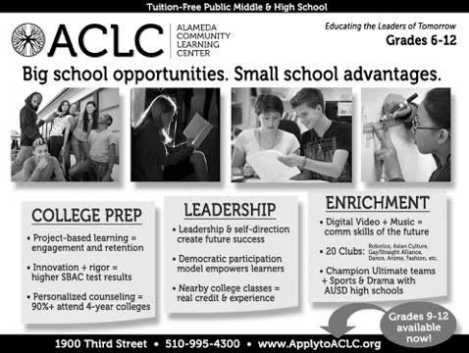
Suspensions and Expulsions
 | December 2015 | Trends
Expulsions | Zero | None
Suspensions by Grade Level | One Suspension | None

IEP and 504 update
 | December 2015 | Pending
504’s | 36 | 1
IEP’s | 31 | 2

