ACLC Lead Facilitator Report – David Hoopes
ACLC Board of Directors
April 18th, 2017
CLCS Transition:
The CLCS board has confirmed the following transition plan for new leadership at CLCS:
- Annalisa Moore will be promoted to the position of Executive Director (ED). Annalisa has repeatedly demonstrated strong, positive leadership within our organization. With her passion for education, determination and high integrity, she embodies the skills needed to see us through challenging times and into a bright future.

Testing Calendar
The 2016–17 California Assessment of Student Performance and Progress administration will include the Smarter Balanced Summative Assessments; the California Alternate Assessments (CAAs), including the CAA for Science pilot; and the California Science Tests (CASTs) pilot. The optional primary language test, the Standards-based Tests in Spanish (STS) for Reading/Language Arts (RLA), will be offered in the form of paper-pencil assessments.
Smarter Balanced Summative Assessments
Students in grades three through eight and grade eleven will take the 2016–17 Smarter Balanced Summative Assessments for English language arts/literacy (ELA) and mathematics. These tests are administered online. A student may be exempted from taking the Smarter Balanced tests in the following three situations:
- If the student is taking the CAAs.
- If the student has been designated as an English learner and is within his or her first 12 months of enrollment in a U.S. school as of April 15 of the previous year. These are consecutive months. (This exemption applies to the ELA portion of the Smarter Balanced Summative Assessment.)
- If the parent has expressed in writing that his or her student should be excluded from taking the summative assessments.
California Alternate Assessments
The CAAs for ELA and mathematics in grades three through eight and grade eleven are individually administered to students who have an individualized education program that indicates the use of an alternate assessment on statewide assessments. All eligible students are required to participate in these online assessments.
The pilot of the CAAs for Science will be administered during the portion of the local educational agency’s (LEA’s) selected testing window that occurs on or after March 20, 2017. These tests are to be administered to eligible students in grades five and eight and grades ten, eleven, or twelve.
California Science Tests Pilot
The pilot of the CASTs will be administered during the portion of the LEA’s selected testing window that occurs on or after March 20, 2017. These tests are to be administered to all students in grades five and eight and to selected students in grades ten, eleven, and twelve.

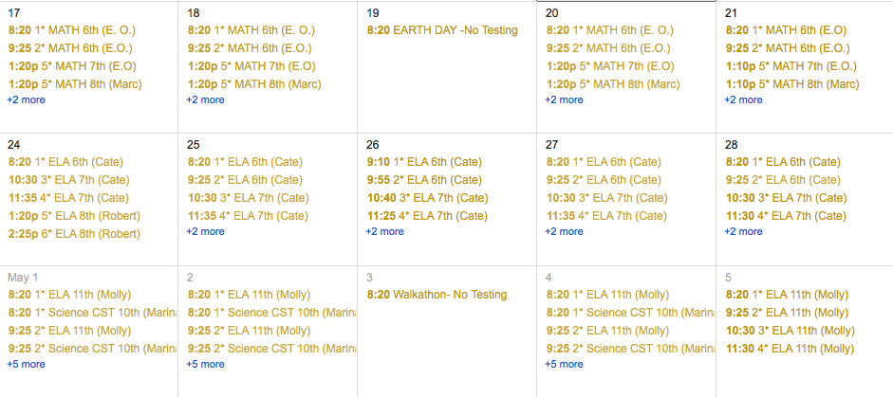

PAC NEWS:
Congratulations again to the 2017 CCEF Chili Cook-off Winners:
3rd place tie: 6th grader Parker Shepard and Family (Team Chill Lee for President) AND Quinton Yap, Gavin Ruport and Jasmine Liu (9th graders) (Team Spice Monkeys)

2nd place: Sara Zhu and Sarafina Bee-Martinelli (9th graders) (Team: Our Chili we'd prescribe, to squash those bad vibes) 1st place: Ben Garcia and Arlo Rucker (7th graders) (Team Chips and Chili)

2017 Chili Cook-off Competitors
- Katie Kovach, 10th grade learner, Name: Katie's Chili
- Daniel Cabrales, facilitator - Team name: 2 Legit 2 Quit
- Rebecca Molina-Aced (mom) and Annalis Molina-Aced (7th grade), Team name: Team Molina
- Sara Zhu and Madison Prior, 9th graders, Team Name: Our Chili We'd Prescribe 2nd Place!!
- Danny Bradac (facilitator), Alexander Bentz and Lee Ann Hill. Team Name: "FOD" Friends of Danny
- Gabriel (Dad) and Parker Shepard, grade 6, Team Name : Chill Lee 3rd Place!
- Ben Garcia and Arlo Rucker (7th graders), Team: "Chips and Chili", 1st Place!!
- Quinton Yap (9th grade), Gavin Ruport (9th), Jasmine Liu (9th) Team: Spice Monkeys 3rd Place!
- Benny Yap (Dad to 9th grader Quinton), "Team Green Envy",
- Oliva Family (Mila, 9th grade, Margo and Jose, Parents and little brother), Team Name : Fantastic Frijoleros
- Philip Milestone, CLCS Board Member, Team: "Carnvivorous Staycation"

Chili Cook Off Committee and Event Helpers:
Rebecca Molina-Aced  Leah Ackerman  Daniel Bautista  Juliette Bleecker  Perry Bleecker  Andy Boretto  Isabelle Burgess-Corkins  Peter Burrows  Christin Cooper  Sarah Daon  Lynn Drogo  Lucian Drogo  Sarah Foltz  Dan Foltz (Music)  Sadie Foltz  Rosanna Franklin  Spencer Franklin | Amy Garcia  Ben Garcia  Chris Garcia  Mark Gleason  Aidan Gleason  Lisa Gleason  Debamitra Guha  Reeth Guha  Dave Hoopes  Christine Kovach  Katie Kovach  Martin Kharrazi  Tina Anh Le Dang  AnneMarie Maes  Alyanna Manzano  Cassandra Waller-Mims | Wendy Moorhouse  Nicole Paetzel  Jim Prior  Jason Siegel  Marty Simmonds  Kim Skuta  Paul Skuta  Tony Steuer  Cheryl Steuer  Avery Steuer  Kris Thornton  Dave Teeters  Lisa Yap  Lihua Zhao

CCEF is grateful for the community's participation and generous support of this event. Funds raised benefit the learners in new grants for field trips, equipment for robotics and so much more!

Multicultural Night
Congratulations also to the team of seniors who put on an absolutely lovely Multicultural Night. The performances, visual arts, food and camaraderie that evening were stunning. Bravo to: Madison Summerfield, Vailea Bohne, Daniel Bautista, Danielle Fernandez and Simone Sanford! Thanks also to the many learners, parents and staff who helped make the event successful. So much talent to celebrate, and what better way to celebrate than with bugs?! Yes, Patricia Williamson's Insect Chefs were present with their magical concoctions. The art that adorned the walls was amazing, and the talent show portion was so much fun! It was a lovely way to spend an evening with the best learners in the world!

DC Trip
This year the 3rd annual 8th Grade DC trip has come and gone with 44 learners visiting our nation's capital for 5 days. Enrollment for families interested in next years' trip will begin at the end of April. 7th grade families, please keep an eye out for an email regarding enrollment, an information meeting, and scholarship opportunities. A special thank you to Daniel Cabrales! For the past 3 years, Daniel has taken the 8th graders to Washington DC to get a close up look at how our government works. This takes extra time and effort to get 40-50 8th graders across country. We want to thank Daniel for this great opportunity for our learners!
Enrollment Update:
Ice Cream Social
All new parents were invited to ACLC’s New Learner Ice Cream Social on Thursday, March 30th from 6:30 – 7:30 pm. Several families have already toured or shadowed at our school. This will be our first opportunity to come together as a community for a first time as part of the ACLC family. Facilitators and current ACLC learners were on hand at event to answer questions and lead games. Also, our administration team was on hand to welcome folks, answer questions and support parents in wrapping up final enrollment details.
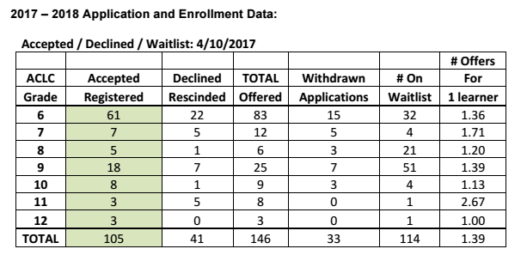

ACLC Intent to return data
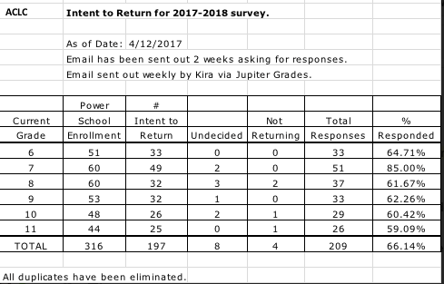

2017-18 Calendar
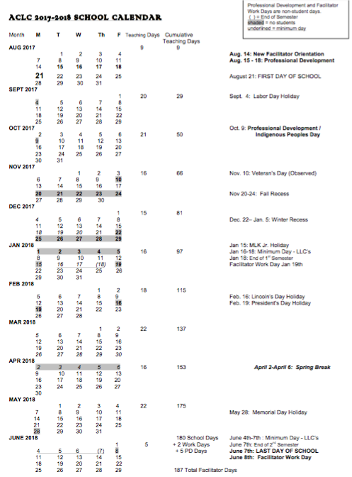

Salute to Education
Each of Alameda’s 20 public schools will have an innovative program honored at the event. The programs and the innovators will be featured on a posters at the venue as well as in keepsake programs. In addition, each school’s outstanding Innovators will be recognized during the event and presented with a token of appreciation for their work.

Adriana Lombard: - Innovator in Education
Juliette Bleecker: -ACLC Volunteer of the Year

The following write ups has been submitted for the Salute to Education program.

Adriana Lombard:
Adri is a gifted and creative young facilitator at our school. Alameda Community Learning Center is lucky to have her. She facilitates three classes at our school. She is our anchor middle school science facilitator, Art of Science electives facilitator and, this year; she is also facilitating a class entitled Social Justice. Social Justice is both an elective for high school and a required ninth grade social studies class.

Adri has a passion for social justice issues and has worked collaboratively with advisers from Yale to create an interesting and rigorous class for our learners. Adri stepped forward last year with the course proposal and developing this course. Her idea was presented to facilitators and widely accepted as a class that would be engaging and contemporary. In the development of this course she was mindful of modern political and social issues that cause our learners to grapple with complicated topics. In class, she has created a culture of listening and acceptance of various viewpoints. She uses instructional strategies such as Socratic dialogue, reading circles and presentation to ensure all learners have a voice in these complicated modern topics. Recently she took the entire ninth grade to the Oakland Museum for a display of Black Panther history and artifacts. Adri's class is both innovative and fascinating. She is a true leader that all educators should emulate when cultivating interesting educational material. We are privileged to have her at Alameda Community Learning Center. She is an innovator!

Juliette Bleecker:
Public charter schools like ACLC are funded by the State of California. But, public education funding at all levels has declined and is subject to delays and shortfalls. Parents such as Juliette Bleecker and our Creative Community Education Foundation (CCEF) make a tremendous difference in the quality of education we provide to our learners at ACLC. Juliette has been involved with Alameda Community Learning Center for the last four years. She has two amazing learners that attend our school. As an active mother at her children's school, she has taken on a variety of exciting projects that have made a tremendous impact across the school. Juliette has participated in organizing a formal banquet, Multicultural Night and Walkathons just to name a few.

Juliette is now our Creative Community Education Foundation President. With the help of our CCEF Board and ACLC community, she has raised money to support after school enrichment programs such as robotics, poetry and music. Also her leadership has led to countless contributions for learner projects such as science fair, yearbook, ultimate Frisbee and field trips. Words cannot describe how amazing Juliet has been as a parent and CCEF Board President. She is consistent, compassionate and deeply devoted to the kids at Alameda Community Learning Center.

Upcoming Events
Monday - April 17, 2017
- ACLC Curriculum Committee3:30 PM
Tuesday - April 18, 2017
- ACLC Board Meeting
- Spring Performance Series12:35 PM
- ACLC Finance Meeting3:30 PM
- Track & Field Meet4:00 PM
Wednesday - April 19, 2017
- Earth Day/Terra Knowledge Day
- Rosie the Riveter field trip8:20 AM to 1:35 PM
- Track & Field Meet4:00 PM
Thursday - April 20, 2017
- CLCS Board Meeting6:45 PM
Friday - April 21, 2017
- Healthy Lunch-Mediterranean Feast12:35 AM to 1:05 PM
Monday - April 24, 2017
- ACLC Personnel Committee3:30 PM
Tuesday - April 25, 2017
- Spring Performance Series12:35 PM
Wednesday - April 26, 2017
- Rosie the Riveter field trip8:20 AM to 1:35 PM
- Track & Field Meet4:00 PM
- CCEF meeting6:45 PM
Thursday - April 27, 2017
- Track & Field Meet4:00 PM

