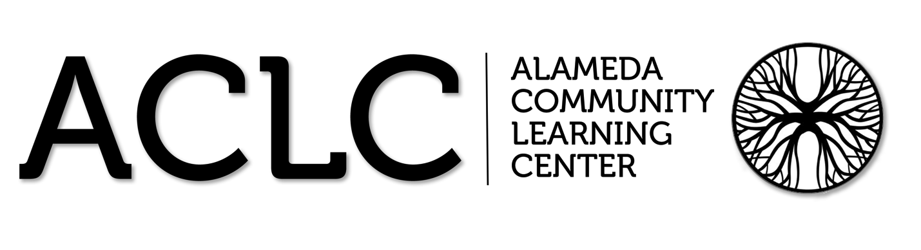

ACLC Lead Facilitator Report – David Hoopes
ACLC Board of Directors’ Planning and Organizational Meeting
October 2nd, 2013

Alameda Community Learning Center
On Tuesday, September 24, ACLC gave a well-attended presentation to senior learners and their parents. Topics included the application process for UC, CSU, and private colleges; Personal Statements, importance of letters of recommendation, SAT and ACT tests, and timeline and important dates for the senior year. Counselor John Maiers and parent Lisa Kharazi each gave a presentation and power point and answered questions. Each senior will also have an individual conference with a counselor to set up a specific senior plan for both graduation and college enrollment. Parents are invited to make individual appointments as well to follow up with their student.

Healthy Lunch

ACLC had its first Healthy Lunch last Friday. It was a huge success. Congratulations to Julie Skowronski for all of her coordination and hard work. Future dateas are as follows:

November 1st : Mexican Food in Honor of Día de Muertos
December 13th : Mac and Cheese With sliced Ham
January 17th : California Soul Food, In Honor of Martin Luther King Jr
February 7th : Chinese Food In Honor of Chinese New Year, 1/31/14 Year of
the Horse
March 7th : Shepherds Pie with Bangers
April 4th : Baked Ziti and Cesar Salad
May 2nd : Vietnamese Pho and Spring Rolls
June 12th ACLC Annual Picnic

CCEF Housewarming

On Friday, October 4th, at 6:30 p.m. in the ACLC courtyard CCEF and PAC are celebrating and supporting ACLC at a Housewarming Fundraiser! The evening is the kick off to this years capital campaign drive. They are hoping to raise 70 thousand dollars for learners at ACLC.

With Special Guest Artists:
- Cosmic Spin
- Groove-Folk with a Cosmic Twist
Please click here: ACLC Housewarming.jpg for more details!

A big change for ACLC is coming. Learners spoke last year at constitutional convention about a mascot. Leadership has responded by hosting a series of votes on the issue. It has been great to start the year in such a true democratic fashion. We are down to the final vote this week at our next CCC, our school will be taking our final votes for our school's final mascot and colors!
- Hydras (Blue and Black)
- Hawks (Purple and White)

Bethany Kharrazi

Bethany Kharrazi went to Washington DC this summer to advocate on behalf of her brother and ACLC graduate Jeremy who is fighting cystic fibrosis. She a leader that other leaders should emulate. Inside Bay Area published this article highlighting her trip to Capital Hill.
http://www.insidebayarea.com/my-town/ci_24073717/alameda-teen-goes-d-c-talks-lawmakers-about Congats to Bethany!

New Signs:
I hope you had a chance to see the new signs in front of the school. Thank you to Bara Waters and Robert Cassard for the creativity and follow through. The signs look great.
