

ACLC Lead Facilitator Report – David Hoopes
ACLC Board of Directors
October 14th, 2015

Summary of report
- Hiring Updates
- WASC Report update
- State SBAC Data overview
- ACLC, State, County, AUSD District results
- Committee Schedule

Hiring Update:

- You may be aware that Clara Wells resigned for health reasons last week. We were all very sorry to hear her news. ACLC will be posting her position and looking to hire a permanent facilitator as soon as possible.

- We have now hired Heather Miles to facilitate science. She is teaching 6th grade Science and 8th Grade Science.
- ACLC has also hired Julie Druyor as our school psychologist. She will be working directly with learners who require short term counseling or extensive counseling as part of an IEP.

-----------------------------------------------------------------------------------------------------------------------------------------------

WASC – WESTERN ASSOCIATION OF SCHOOLS and COLLEGES

WASC work is continuing with staff. Lynne Boone is leading this work along with the WASC Leadership team. In our last professional development day, facilitators established focus groups and began developing assignments and evidence tools for writing the report. The Leadership team has developed surveys and observation tools collect data. Focus groups began to grapple with the prompts and questions that are essential for writing the report.

-----------------------------------------------------------------------------------------------------------------------------------------------

State SBAC Data
ACLC did very well in this first round of SBAC Results. We had some of the top results in the city. Although we did not focus on teaching the test, we are sure that working to transition to the common core curriculum two years ago was a factor in high achievement. The assessments were challenging to implement. However, we feel these assessments are superior to previous assessments (STAR). Like class assignments and report cards, assessments are one gauge of student progress, providing information to schools, teachers, and parents about how students performed in terms of California’s challenging new goals for learning.

Parents/guardians of students in grades three through eight and grade eleven are mailed Student Score Reports for the California Assessment of Student Performance and Progress (CAASPP). These reports include detailed information about their child’s performance on new, computer-based tests for English language arts/literacy (ELA) and mathematics, which replaced the former paper-based assessments.

Students receive an overall score for each subject, ranging from 2,000 to 3,000. Overall scores are reported within one of four levels: standard exceeded, standard met, standard nearly met, and standard not met.

The new score reports also highlight students' strengths in key areas for both ELA and mathematics. ELA results include information about the students' performance in the areas of reading, writing, listening, and research. Reports of mathematics results include information about students' performance in problem solving, using concepts and procedures, and communicating mathematical reasoning. The student's performance in these key areas for each subject are reported using the following three indicators: below standard, at or near standard, and above standard.

For students in grade eleven, individual reports also will indicate their readiness for credit-bearing, college-level work and, if further preparation is needed, which areas to focus on in their senior year. For many students, that is the kind of information that can help make the dream of a college education become a reality.

For students in grades five and eight, Student Score Reports also will include student scores from the California Standards Tests for Science, a requirement of the federal government. California is in the process of developing a new state science assessment aligned with recently adopted science standards. California may also develop new assessments in other subjects, including history–social science aligned with state-adopted content standards.

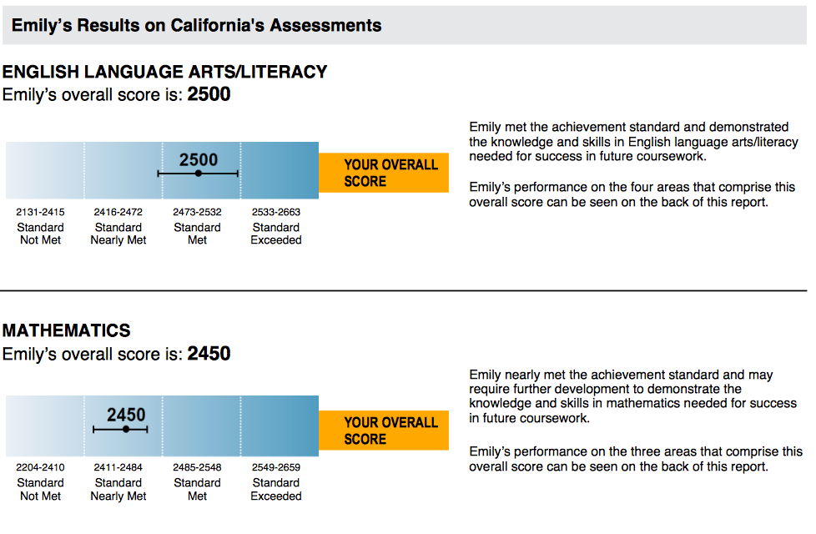

Like the new learning goals they were designed to measure, the CAASPP tests for ELA and mathematics are too fundamentally different from the old assessments to make any reliable comparisons between old scores and new. That is why this year’s scores are better thought of as a starting point—a baseline for the progress students are expected to make over time.
Gradually, California is providing more support for teachers, more resources for students, and more access to technology. Because this is the first year students are taking these new tests, overall scores may be viewed as a basis from which to compare performance in future years.

Many if not most students may need to make significant progress to reach the standards set for mathematics and ELA that indicate college and career readiness. No student, parent, or teacher should be discouraged by scores, which will not be used to determine whether a student moves on to the next grade. Rather, the results can help guide discussions among parents and teachers, as well as help teachers and schools adjust instruction to meet student need.

Our results, State, County and District results are below:

Test Results for:
Alameda Community Learning Center School
CDS Code: 01-30609-0130609
Alameda Community Learning Center District
Alameda County
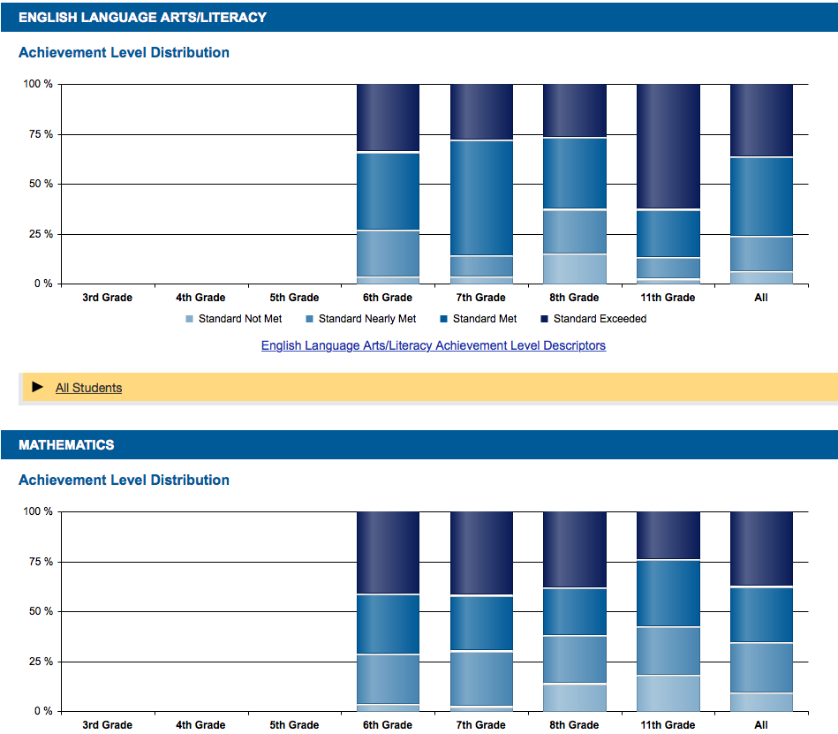

Test Results for:
State of California

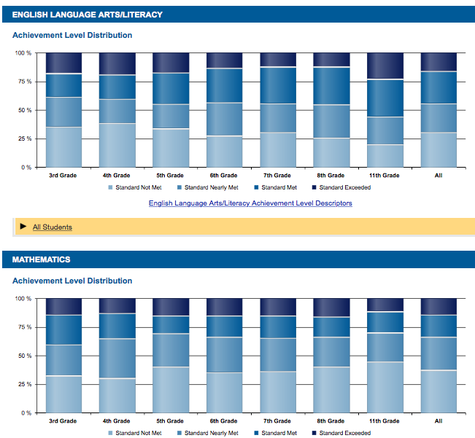

Test Results for:
Alameda Unified District
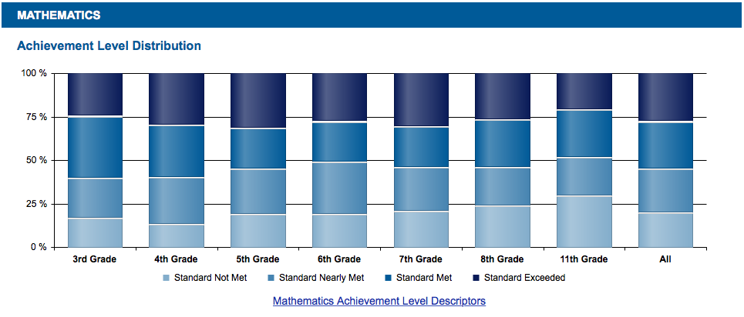

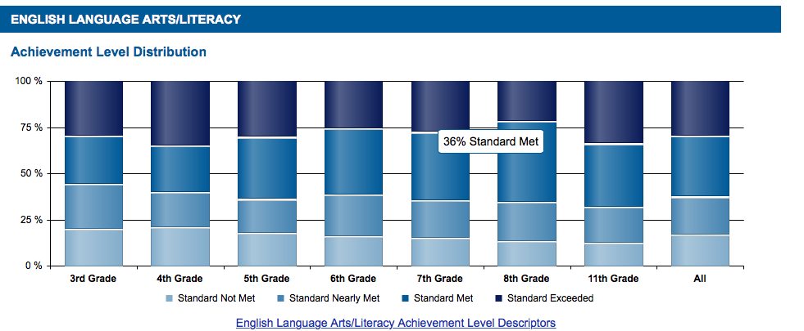

Test Results for:
Alameda County
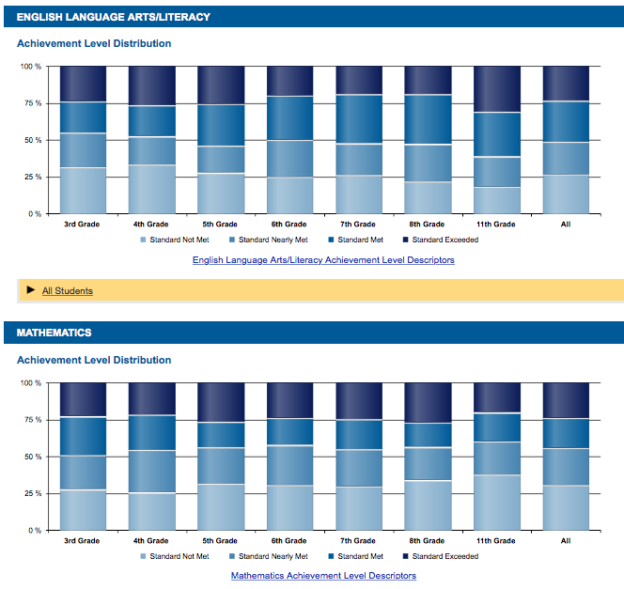

ACLC Committee Schedule
September | Committee | Date | Time | Chair | Location | ACLC Board meeting dates
 | Curriculum | Mon, Sept 28th, 2015 | 3:30 | Molly F. | Room 16
October | Committee | Date | Time | Chair | Location | Wed, Oct 15th @ 6:30
 | Finance | Mon, Oct 5th, 2015 | 3:30 | Patti W. | Room 13
 | Program Eval | Mon, Oct 12th, 2015 | 3:30 | Madeline E. | Room 17
 | Personnel | Mon,Oct 19th ,2015 | 3:30 | David H. | Conference
 | Curriculum | Mon, Oct 26th,2015 | 3:30 | Molly F. | Room 16
November | Committee | Date | Time | Chair | Location | Wed, Nov 4th @ 6:30
 | Finance | Mon, Nov 2nd, 2015 | 3:30 | Patti W. | Room 13
 | Program Eval | Mon, Nov 9th, 2015 | 3:30 | Madeline E. | Room 17
 | Personnel | Mon, Nov 17th, 2015 | 3:30 | David H. | Conference
 | Curriculum | Mon, Nov 30th, 2015 | 3:30 | Molly F. | Room 16
December | Committee | Date | Time | Chair | Location | Wed, Dec 9th @ 6:30
 | Finance | Mon, Dec 7th, 2015 | 3:30 | Patti W. | Room 13
 | Program Eval | Mon, Dec 7th, 2015 | 3:30 | Madeline E. | Room 17
 | Personnel | Mon, Dec 14th ,2015 | 3:30 | David H. | Conference
 | Curriculum | Mon, Dec 14th ,2015 | 3:30 | Molly F. | Room 16
January | Committee | Date | Time | Chair | Location | Wed, Jan 13th @ 6:30
 | Finance | Mon, Jan 4th, 2015 | 3:30 | Patti W. | Room 13
 | Program Eval | Mon, Jan 11th, 2015 | 3:30 | Madeline E. | Room 17
 | Personnel | Mon, Jan 18th ,2015 | 3:30 | David H. | Conference
 | Curriculum | Mon, Jan 25th ,2015 | 3:30 | Molly F. | Room 16
Feb | Committee | Date | Time | Chair | Location | Wed, Feb 10th @ 6:30
 | Finance | Mon, Feb 1st, 2015 | 3:30 | Patti W. | Room 13
 | Program Eval | Mon, Feb 8th, 2015 | 3:30 | Madeline E. | Room 17
 | Personnel | Mon, Feb 15th, 2015 | 3:30 | David H. | Conference
 | Curriculum | Mon, Feb 29th, 2015 | 3:30 | Molly F. | Room 16
March | Committee | Date | Time | Chair | Location | Wed, March 9th @ 6:30
 | Finance | Mon, March 7th , 2015 | 3:30 | Patti W. | Room 13
 | Program Eval | Mon, March 14th , 2015 | 3:30 | Madeline E. | Room 17
 | Personnel | Mon, march 21st, 2015 | 3:30 | David H. | Conference
 | Curriculum | Mon, March 28th , 2015 | 3:30 | Molly F. | Room 16
April | Committee | Date | Time | Chair | Location | Wed, April 13th @ 6:30
 | Finance | Mon, April 4th ,2015 | 3:30 | Patti W. | Room 13
 | Program Eval | Mon, April 11th ,2015 | 3:30 | Madeline E. | Room 17
 | Personnel | Mon, April 18th ,2015 | 3:30 | David H. | Conference
 | Curriculum | Mon, April 25th,2015 | 3:30 | Molly F. | Room 16
May | Committee | Date | Time | Chair | Location | Wed, May 11th @ 6:30
 | Finance | Mon, May 2nd, 2015 | 3:30 | Patti W. | Room 13
 | Program Eval | Mon, May 9th, 2015 | 3:30 | Madeline E. | Room 17
 | Personnel | Mon, May 16th, 2015 | 3:30 | David H. | Conference
 | Curriculum | Mon, May 23rd, 2015 | 3:30 | Molly F. | Room 16
June | Committee | Date | Time | Chair | Location | Wed, June 8th @ 6:30
 | Finance | Mon, June 6th, 2015 | 3:30 | Patti W. | Room 13

Enrollment widow is opening for 2015-16
Though the school year has already started, we are still accepting applications for the 2015-16 school year. While some grades are fully enrolled, there remain a few open spots in certain grades.

Admissions for next school year - 2016-17:
ACLC will begin accepting applications for the 2016-17 school year on October 19, 2015.
Please do not apply for next year before that date, or your application will not be valid and your child will not be added to the waitlist. All applications received between October 19, 2015 and January 31, 2016 will be entered into our lottery held on February 3, 2016. If a child is accepted in the lottery, families will receive notification both by letter and email, and will have a specified amount of time to accept or decline that acceptance.
If a child is not selected in the lottery, the child's name will be placed on the waitlist for their grade, according to the order in which their application was received. Once the lottery notification period has passed, we will begin making offers from the waitlists.

The ACLC charter provides that Alameda residents, children of staff and board members and siblings of current attendees of ACLC are granted priority admission status.
FAMILY INFORMATION SESSIONS & SCHOOL SITE TOURS

Family Information Sessions:

Info Sessions are Wednesdays @

6:15 pm - middle school / 7:30 pm - high school

October 21, 2015

November 4, 2015

December 9, 2015

January 20, 2016

February 17, 2016

March 23, 2016

April 20, 2016

May 18, 2016

School Site Tours:

Tours are Wednesdays @ 9:00 am

(No reservations required!)

October 28, 2015

November 18, 2015

December 16, 2015

January 27, 2016

February 24, 2016

April 6, 2016

April 27, 2016

May 25, 2016

