October Assessment and Accountability Committee Agenda

1st) These goals were created late last year. They were developed using the results from our end of year survey of staff. Please review these goals and update as you see fit. The Google sheet to review and is linked on the agenda. Some of the data we used to develop these goals is below.

Assessment and Accountability Committee Goals:
Committee |  | Members
Assessment and Accountability |  | David Hoopes | Caroline S. | Christopher Elliott-Avakian
 |  | Robert Clark | Amy W. | Amanda S.
 |  | Jalen Black | Liz P.
Goal | Goal |  | Goal | Goal |  | Goal |  | Goal
Assessment committee will develop and deliver P.D. for:  MAP, Juno (in-house)  Juno: if possible, by the end of this 19/20 year | Assessment committee will ensure that MAP and CAASPP results are shared in a timely manner in all ways  Including making returning learners’ MAP data available for facilitators before throughout our school year. |  | Assessment committee will Facilitate discussions among staff about changing MAP testing schedule—at the end of 2019 school year.  Including for math department using the MAP screening or subject tests instead of growth assessments. | Assessment committee will gather and share assessment data from all sources and subjects. This will include History, Science and VPA. |  | Assessment committee will promote, support and track projects as holistic assessments at ACLC. |  | The Assessment and Accountability group will work directly with the WASC Leadership Team to inform the 2019-20 WASC work.
Metric for Success | Metric for Success |  | Metric for Success | Metric for Success |  | Metric for Success |  | Metric for Success
End of year A&A survey | Deliverable and timeline met. |  | Staff all had a chance to give input on MAP testing schedule | All classes have benchmark assessment data available in Jupiter |  | Project Tracking and assessment tool  PBL professional Development sessions |  | Successful fulfillment of WASC visiting Committee expectations for WASC goal #1.
Measurement Methods | Measurement Methods |  | Measurement Methods | Measurement Methods |  | Measurement Methods |  | Measurement Methods
End of year A&A survey shows 90% of staff feel prepared and informed on how to create pods, and analyze learner results using Juno. | All current learners 2018/19 MAP data is shared prior to school year.  2018/19 CAASPP results are shared digitally within one week of ED Tech release |  | 90+% of staff say that they had a chance to give input in the Assessment & Accountability survey | Interdepartmental competition: who can find assessment data on a random set of students the fastest?  Juno to checked to assess that assessment data exists for all classes |  | ACLC A and A facilitators survey will show and increase in authentic projects at ACLC  The Project tracking tool will show an increase in overall projects within each department across ACLC.  The Assessment and Accountability Committee will lead trainings with new (3) and returning (2) facilitators to increase PBL across the school. |  | ACLC will have a positive mid term visit that results in affirming the next 3 years of WASC accreditation.

At the end of last year, the Assessments and accountability team looked at the survey administered to staff regarding Assessment tools used at ACLC. Below are our findings and some of the key data from the meeting. In addition to what you see below, some questions required narrative responses. We chose not to share those responses due to privacy.

4 glaring strengths revealed in the data
- The development of this committee proved critical during WASC. The school was complimented on the amount of useful data and information about the progress of learning at ACLC.
- Staff are utilizing benchmarks and know the purpose for benchmarks
- Implementation of MAP has been a success
- On the spot checks for understanding are being used regularly

3 areas to grow reveled in the survey
- Juno assessment needed additional professional development for staff.
- ACLC should leverage staff that are using Juno successfully
- More discussion time and continues use of data are needed in LOC work

Next steps for A & A Committee and ACLC
- Hold a staff discussion about homework to discuss rate of return.
- Establish school wide AND individual learner motivation strategies for MAP and CAASPP. Staff needs to see each other’s ideas and best practices.
- The committee needs to facilitate a staff discussion in order to reframe the communication norms between resource facilitators and classroom facilitators around assessment and instruction.

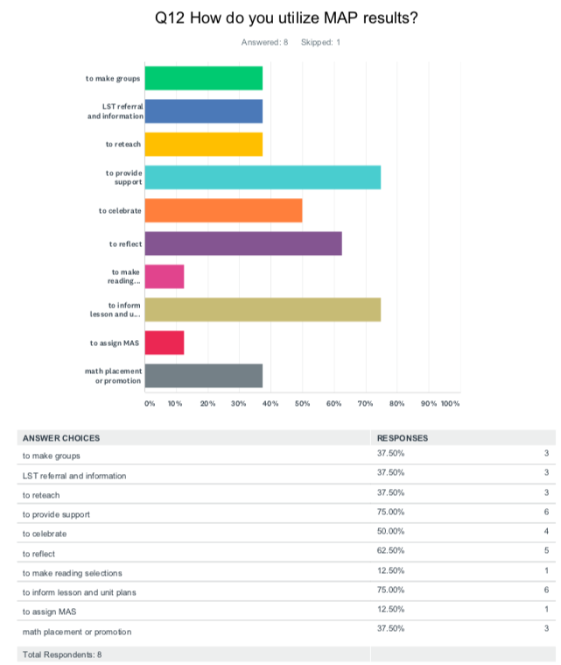
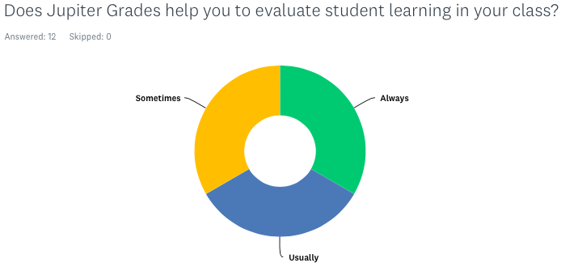

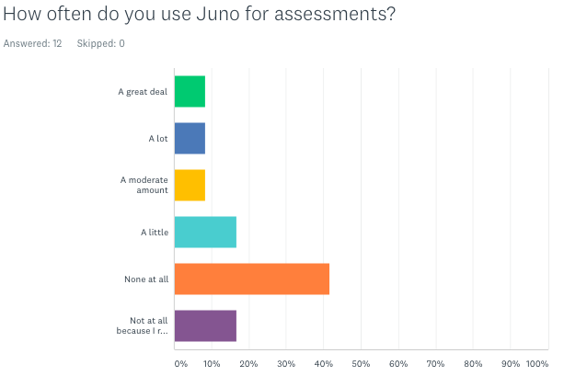

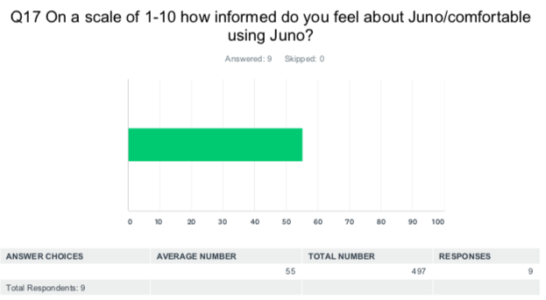

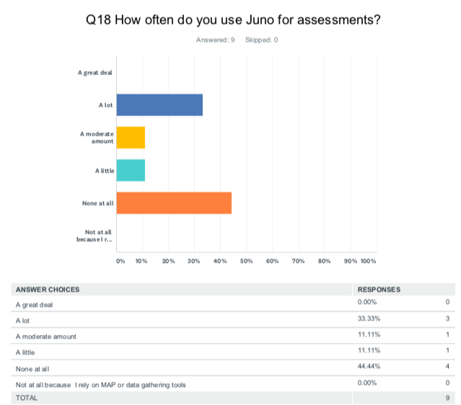

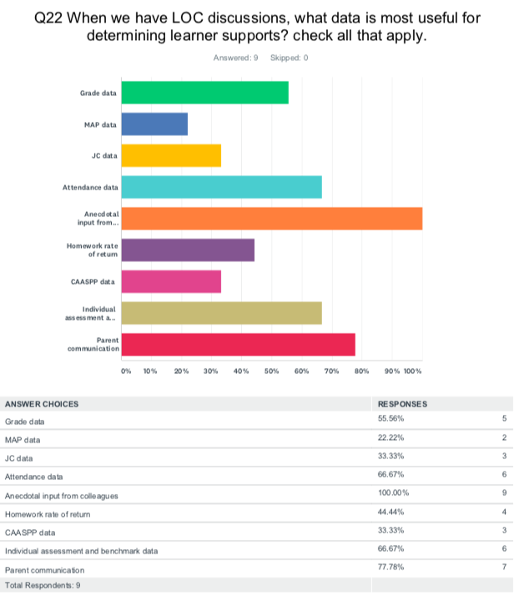
ACLC Change in Demographics
 | Fall 2014-15 | Fall 2018-19
Socioeconomically Disadvantaged | 54 | 119
Alameda Residents | 78% | 66%
Learners w/ disabilities | 24 | 24
504 Learners | 14 | 32
ELL | 29 learners (7.7%) | 40 Learners (11.4%)
Foster Youth | 0 | 1
Homeless Youth | 1 | 9

ACLC |  | 2014-15 |  | 2018-19
 | African American | 5% | up to | 8.%
 | American Indian | 0.3% |  | 0.0%
 | Asian | 19% | up to | 23%
 | Filipino | 5% | up to | 4%
 | Hispanic | 15% | up to | 13%
 | Pacific Islander | 0.0 | - | 0.0
 | White | 43% | down to | 33.%
 | 2 or More races | 12% | down to | 11%

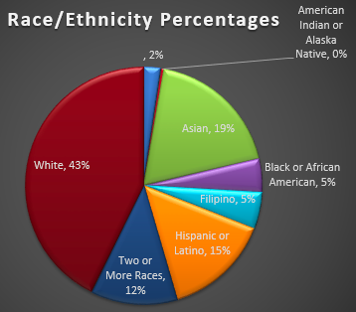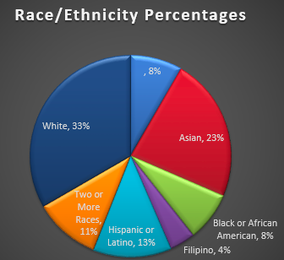

The Dashboard
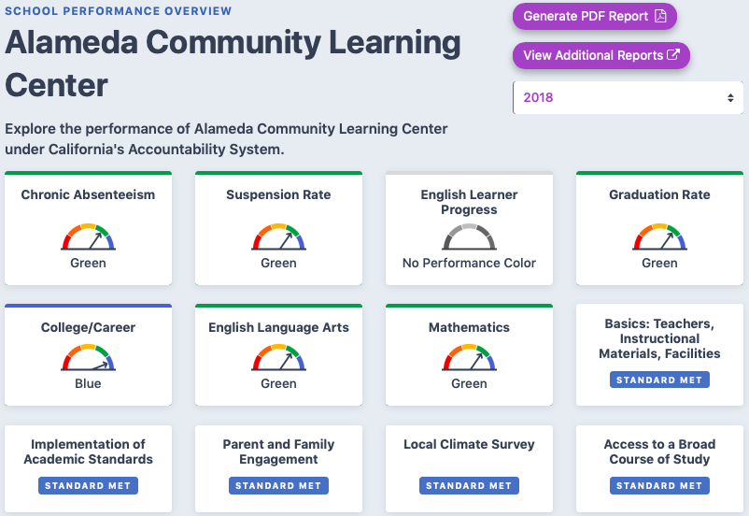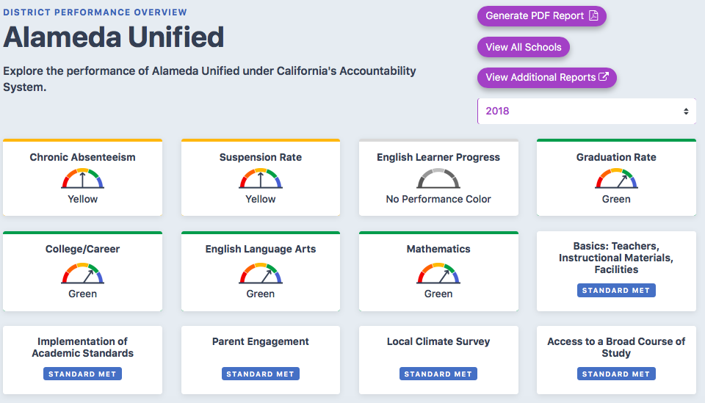

https://www.caschooldashboard.org

CAASPP Performance last year
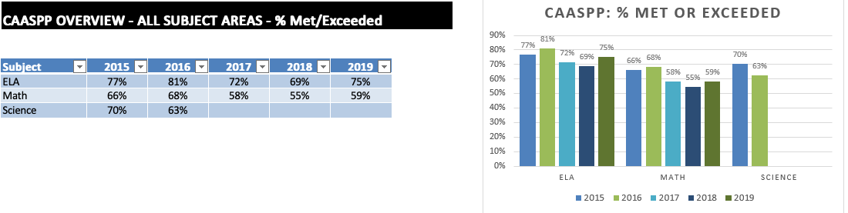

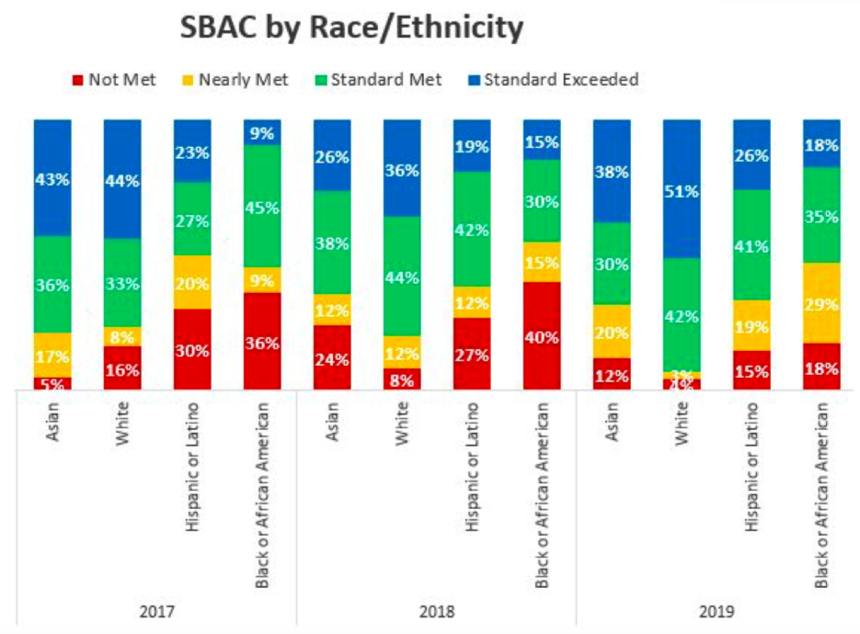

Staff Retention

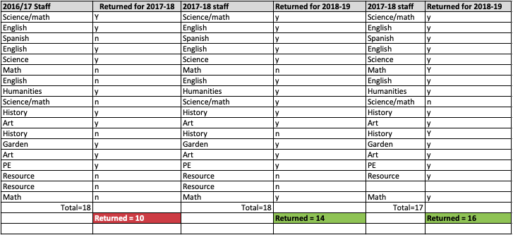

GPA
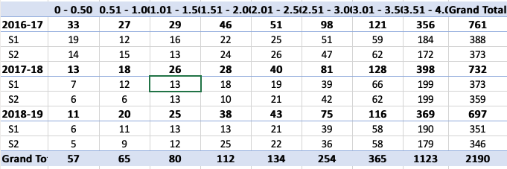

ELL Learners
