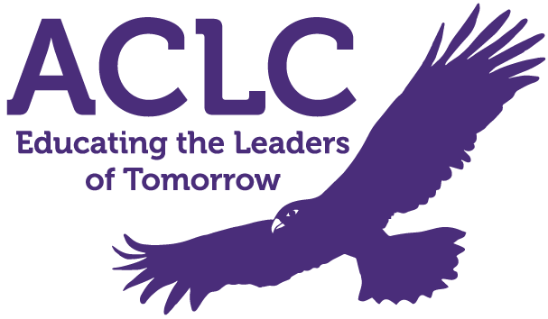
Alameda Community Learning Center
ACLC Special Governing Board Meeting Agenda

October 22nd, 2020 – 5:50PM - 7:30PM

This meeting will be held via public Zoom:
https://us02web.zoom.us/j/89350108031
Meeting ID: 893 5010 8031

- Public Session (ACLC) 5:50 PM

- Call to Order & Attendance
Meeting is called to order at ______________

Board Members Present Absent

Michael McCaffrey, ACLC Lead Facilitator ______ ______
Robert Clark, ACLC Facilitator ______ ______
Daniel Cabrales, ACLC Facilitator ______ ______
Kimberly Skuta, ACLC Parent Member ______ ______
Kaia Foster, ACLC Learner ______ ______
Jim Kaufman, Community Member ______ ______
Open Seat, ACLC Learner ______ ______
Open Seat, ACLC Parent Member ______ ______
Open Seat, Community Member ______ ______

- Review and Approval of Agenda

- Presentations from the floor 6:00 PM
PRESENTATIONS FROM THE FLOOR - At this time any person wishing to speak to any item not on the agenda will be granted three minutes to make a presentation to the Board of Directors.

PRESENTATION ON AGENDA ITEMS – Any person wishing to speak to any item on the agenda will be granted three minutes to make a presentation just prior to the discussion of the agenda item.

- Presentation 6:10 PM
- Brown Act and Conflict of Interest Training
Presented by: Eric Stevens from Girard, Edwards, Stevens & Tucker LLP

- Adjournment 7:30 PM

THE ORDER OF BUSINESS MAY BE CHANGED WITHOUT NOTICE
Notice is hereby given that the order of consideration of matters on this agenda may be changed without prior notice.

REASONABLE LIMITATIONS MAY BE PLACED ON PUBLIC TESTIMONY
The Board of Directors’ presiding officer reserves the right to impose reasonable time limits on public testimony to ensure that the agenda is completed.

SPECIAL PRESENTATIONS MAY BE MADE
Notice is hereby given that consistent with the requirements of the Bagley Open Meeting Act, special presentations not mentioned in the agenda may be made at this meeting. However, any such presentation will be for information only.

REASONABLE ACCOMMODATION WILL BE PROVIDED FOR ANY INDIVIDUAL WITH A DISABILITY
Pursuant to the Rehabilitation Act of 1973 and the Americans with Disabilities Act of 1990, any individual with a disability who requires reasonable accommodation to attend or participate in this meeting of the Board of Directors may request assistance by contacting Community Learning Center School, Inc., 1900 Third Street, Alameda, CA 94501, phone 510-995-4300, fax 510-995-4307.

FOR MORE INFORMATION
For more information concerning this agenda or for materials pertaining to the board meeting, please contact Community Learning Center Schools, Inc.,1900 Third Street, Alameda, CA 94501, phone (510) 263-9957, during school hours

